Name: _______________________ ID: __________________

We will use MS SQL Server Expres Edition and Microsoft SQL Server Management Studio.
At the beginning delete all DBs on your server!
Create folder DBPartTime062026 on drive C (C:\ DBPartTime062026).
Download DB backup file School.bak and DB_PartTime_01062026.docx in C:\ DBPartTime062026
Restore database from backup file (attached on moodle) : School.bak
Provide SQL statements in the table below and screens from the output (whole screen) in the table or save them as pictures with appropriate name in C:\ DBPartTime062026

- [10 Points] ER Diagrams (in WORD)

A company with a store chain wants to have an application for better products supply activities recording. The company has the following structure: It has several stores, and each store is of some type: shop-store, supermarket or discount (in the future, there can be new store types). For every store, besides its type, there are data such: as location (address), manager, and size (m2).

On the other hand, the company has its own warehouses. Every warehouse has a specific name and phone. Every warehouse can deliver products in every store, and every store can ask for products from every warehouse. The supply activity has two important data: the date of supply and the list of products.

According to the given text, define ENTITIES, RELATIONS, and Attributes, define relational cardinalities and constraints, create ER diagram and describe the meaning of relational cardinalities.

Write down 3 instances/examples for each ENTITY.

Note: Use https://app.diagrams.net or Draw.io for the diagram preparation and then paste in a WORD document named by your name and ID.

- [10 Points] Table model from ЕR diagram
Use the given ER Diagram and create ER model (table model) for the database. Then, write the instance plan, i.e. how you will initially insert data if you suppose to create a database according to that ER Model.
(if you can’t find any ER diagram attribute that can be defined as primary key, create your own)
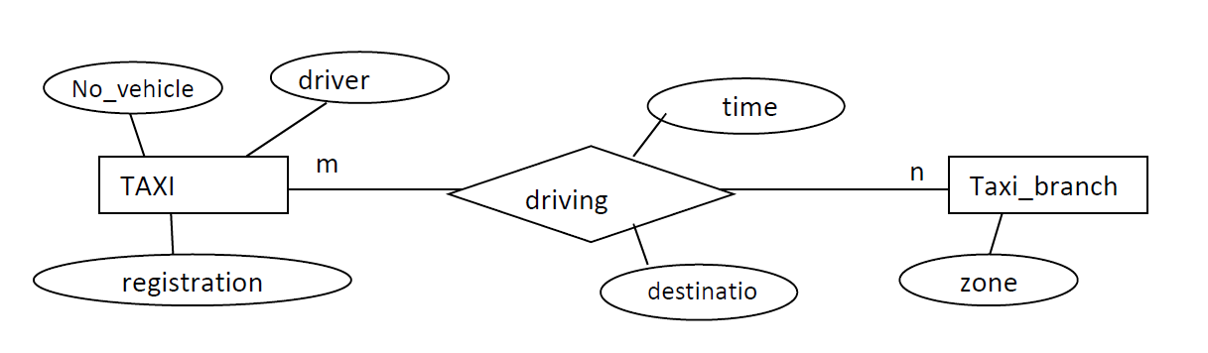
Write 3 instance/example for each Entity or Relation with info for data type, size, mandatory or not.

Note: Use https://app.diagrams.net or Draw.io for the ER model preparation and then paste in the WORD document named by your name and ID. Instances should be written in Word.

- 1) [3 Points] Find all courses (title, credits) and Department name for each department and course where we have more than 3 credits.

SQL
Screen from SQL execution

2) [3 Points] Insert 3 (three) new students in the table Person and 1(one) new Instructor

SQL
Screen from SQL execution

3) [4 Points] Insert DB Course with 4 credits and ID 5011from ICT department with
budget of 500000 and start date 01-October-2024

Insert DDB Course with 6 credits and ID 5022 from ICT department with budget of
700000 and start date 01-February-2025

Show new records from the respective tables in DB.

SQL
Screen from SQL execution

4) [1 Points] Insert new CourseInstructor for DD and DDB.

SQL
Screen from SQL execution

- 1) [5 Point] Find info for each student (First and Last Name, enrolment date), course name credits for the course and department name.

SQL
Screen from SQL execution

2) [6 Points] Find the number of students per course. In the output we need to see number of students and course name.

SQL
Screen from SQL execution

3) [6 Points] Find the number of students per department. In the output we need to see number of students and department name.

SQL
Screen from SQL execution

- [2 Point] Create backup from this DB (save backup file on new folder backup in C:\ DBPartTime062026) – Note: if missing rows from task 3 than 0.5 Points if backup is ok.

Create zip file C:\ DBPartTime062026 from this folder (word document, and backup file, screens and othere related info) and upload this file on moodle.

